**Lab: Lab Assessment Semester: Spring 2023**

**Time Allowed: 90 Minutes Marks: 10**

**Question1:**

**Create given webpage using html, CSS, JavaScript, php.**

1. **Login Page**

* Develop a login page featuring form fields for entering username and password.
* Implement form validation to ensure accurate user input and display alerts.

1. **Admin Dashboard :**

* Design an admin dashboard interface where administrators can conveniently add new products, providing details such as name, price, and image.

1. **Available Products**

* Display the newly added products in the "Available Products" section for easy reference.

1. **Cookie Creation:**

* Upon successful login, establish a cookie containing the username.
* 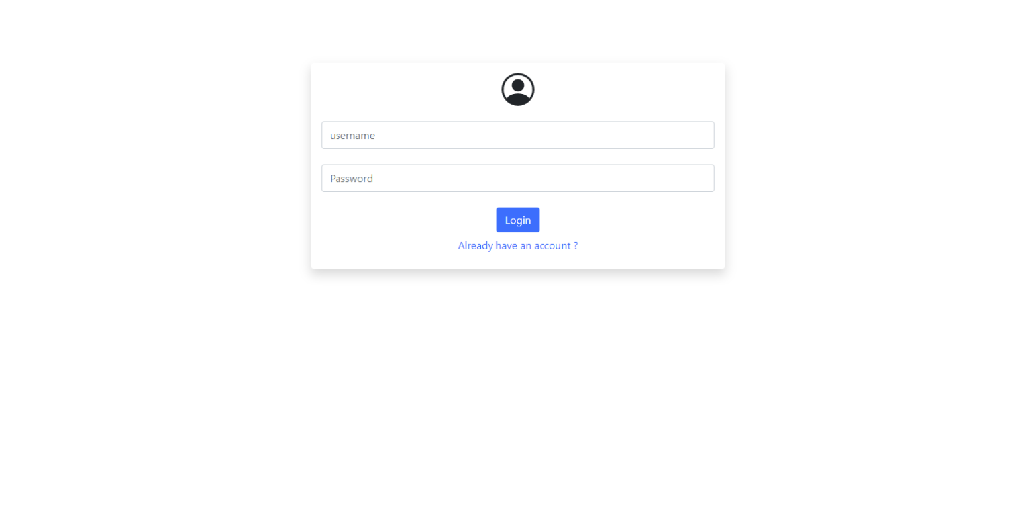Promptly after user login, present a confirmation message indicating the successful creation of the cookie, set to appear one minute post-login.

